Student’s name | …………………………………………………….…… | Grade | 2
Subject | Computer | Quiz No. | 1
Quiz No. ( 1 )

10

write the correct name of each part.

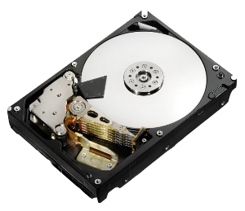


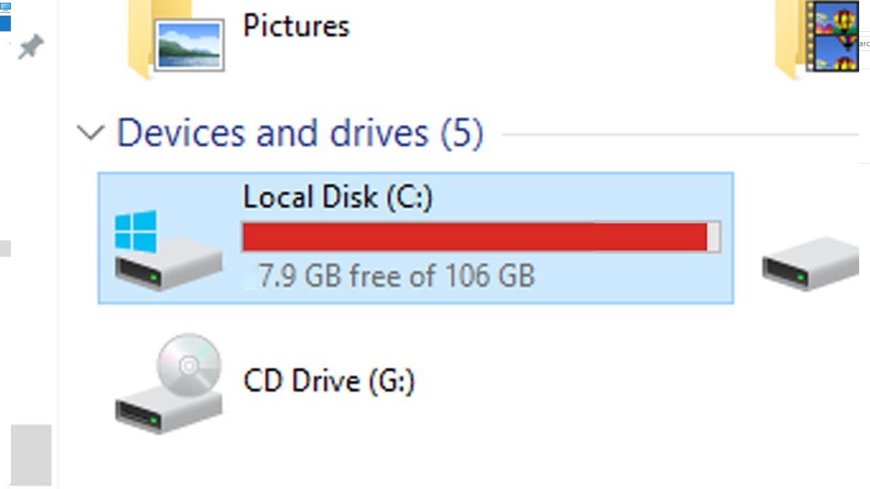
Good Luck

C: Drive
Folder
Vector
File
Hard Disk

